**Experimental Results**

* Prepare the GPU Environment

1) Path of the files used to build the experiments

holger2022@DESKTOP-HAT96CV:~$ tree /home/holger2022/SDE-Net-program

/home/holger2022/SDE-Net-program

├── LICENSE

├── MNIST

│   ├── calculate_log.py

│   ├── data_loader.py

│   ├── models

│   │   ├── __init__.py

│   │   ├── __pycache__

│   │   │   ├── __init__.cpython-36.pyc

│   │   │   ├── resnet.cpython-36.pyc

│   │   │   ├── resnet_dropout.cpython-36.pyc

│   │   │   └── sdenet_mnist.cpython-36.pyc

│   │   ├── resnet.py

│   │   ├── resnet_dropout.py

│   │   └── sdenet_mnist.py

│   ├── resnet_dropout_mnist.py

│   ├── resnet_mnist.py

│   ├── sdenet_mnist.py

│   └── test_detection.py

├── README.md

├── SVHN

│   ├── calculate_log.py

│   ├── data_loader.py

│   ├── models

│   │   ├── __init__.py

│   │   ├── __pycache__

│   │   │   ├── __init__.cpython-36.pyc

│   │   │   ├── __init__.cpython-37.pyc

│   │   │   ├── resnet.cpython-36.pyc

│   │   │   ├── resnet.cpython-37.pyc

│   │   │   ├── resnet_dropout.cpython-36.pyc

│   │   │   ├── resnet_dropout.cpython-37.pyc

│   │   │   ├── sdenet.cpython-36.pyc

│   │   │   ├── sdenet_mnist.cpython-36.pyc

│   │   │   └── sdenet_mnist.cpython-37.pyc

│   │   ├── resnet.py

│   │   ├── resnet_dropout.py

│   │   └── sdenet.py

│   ├── resnet_dropout_svhn.py

│   ├── resnet_svhn.py

│   ├── sdenet_svhn.py

│   └── test_detection.py

├── YearMSD

│   ├── DNN_mc.py

│   ├── SDE_regression.py

│   ├── calculate_log.py

│   ├── data_loader.py

│   ├── models

│   │   ├── DNN.py

│   │   ├── DNN_mcdropout.py

│   │   ├── __init__.py

│   │   ├── __pycache__

│   │   │   ├── DNN.cpython-36.pyc

│   │   │   ├── __init__.cpython-36.pyc

│   │   │   └── sdenet.cpython-36.pyc

│   │   └── sdenet.py

│   ├── test_detection_mc.py

│   └── test_detection_sde.py

└── figure

└── illustration.png

2) Copy files to storage of Polytech’s University Supercomputer Center

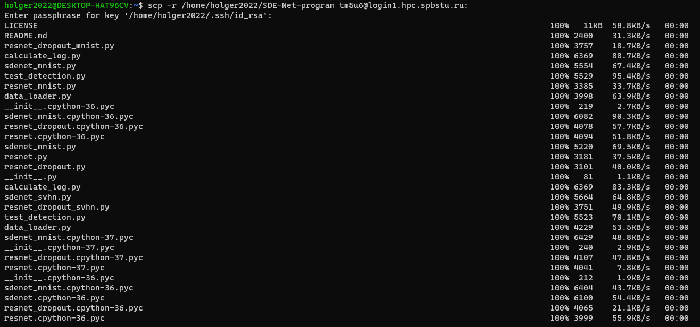

Figure 1. Linux command to copy all files and directories of project to supercomputer

3) Connection via SSH with the supercomputer

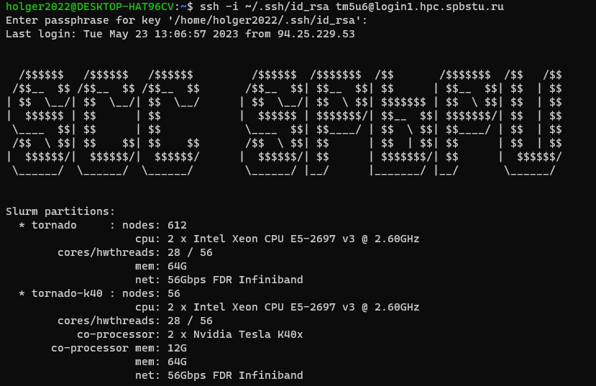

Figure 2. Linux command to make SSH connection with SCC SPBPU

4) Allocate 1 node for GPU-cluster in SCC

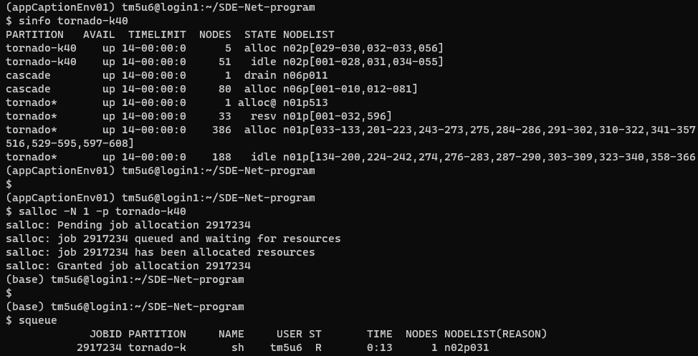

Figure 3. Allocation of node in GPU Tesla k-40

**EXPERIMENTS WITH MNIST**

* Experiment with MNIST – Training Resnet

Command: $ python resnet_mnist.py

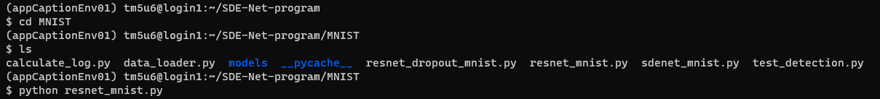

Loading of dataset

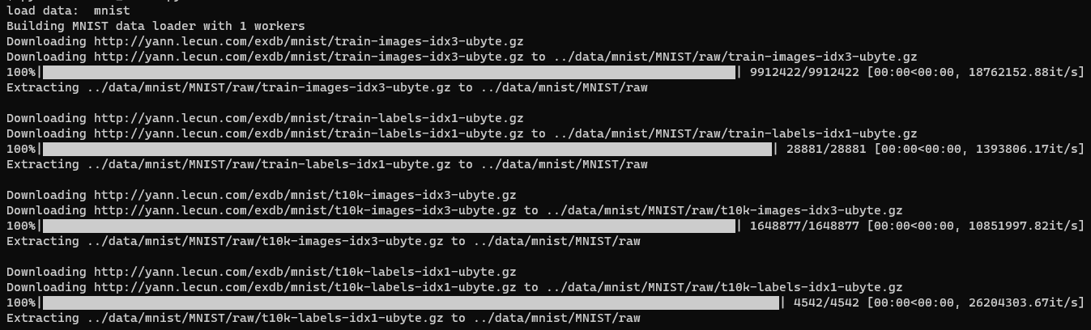

Building and training of the model

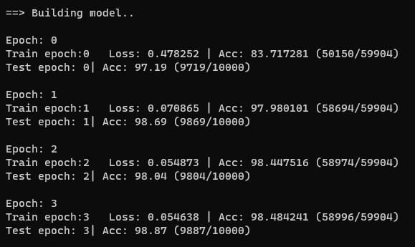

40 epochs after…

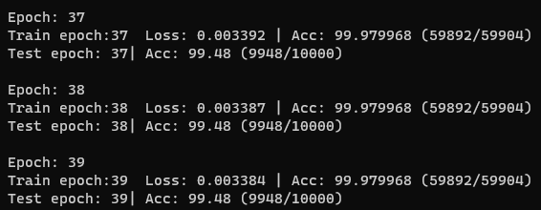

* Experiment with MNIST - Evaluating Resnet

Command: $ python test_detection.py --pre_trained_net save_resnet_mnist/final_model --network resnet --dataset mnist --out_dataset svhn

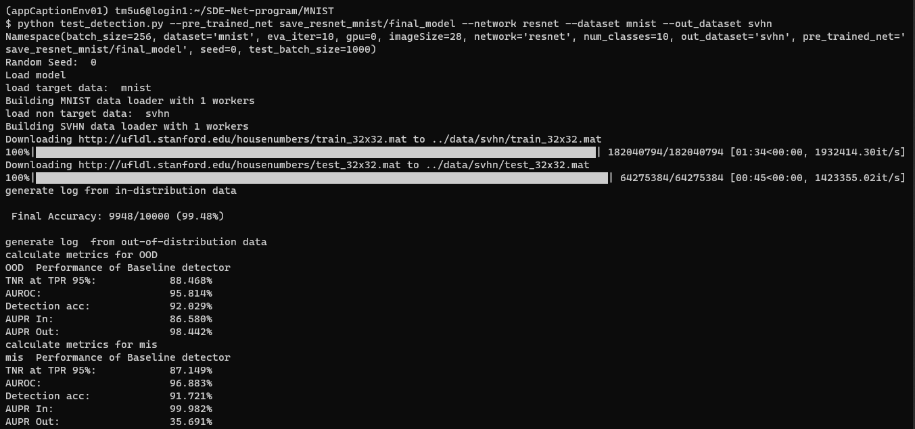

Figure 4. Final Performance results for Resnet in MNIST

* Experiment with MNIST – Training MC-dropout

Command: $ python resnet_dropout_mnist.py

Building and training the model

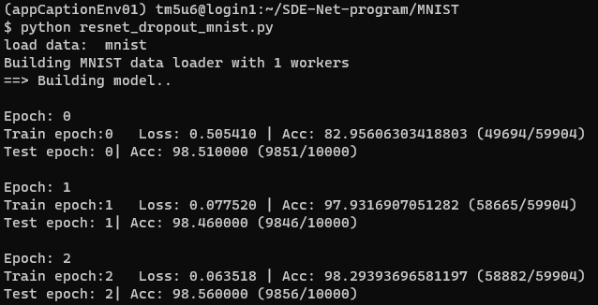

40 epochs after…

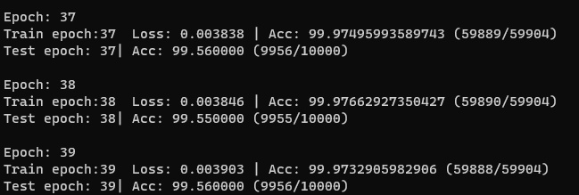

* Experiment with MNIST – Evaluating MC-Dropout

Command: $ python test_detection.py --pre_trained_net save_resnet_dropout_mnist/final_model --network mc_dropout --dataset mnist --out_dataset svhn

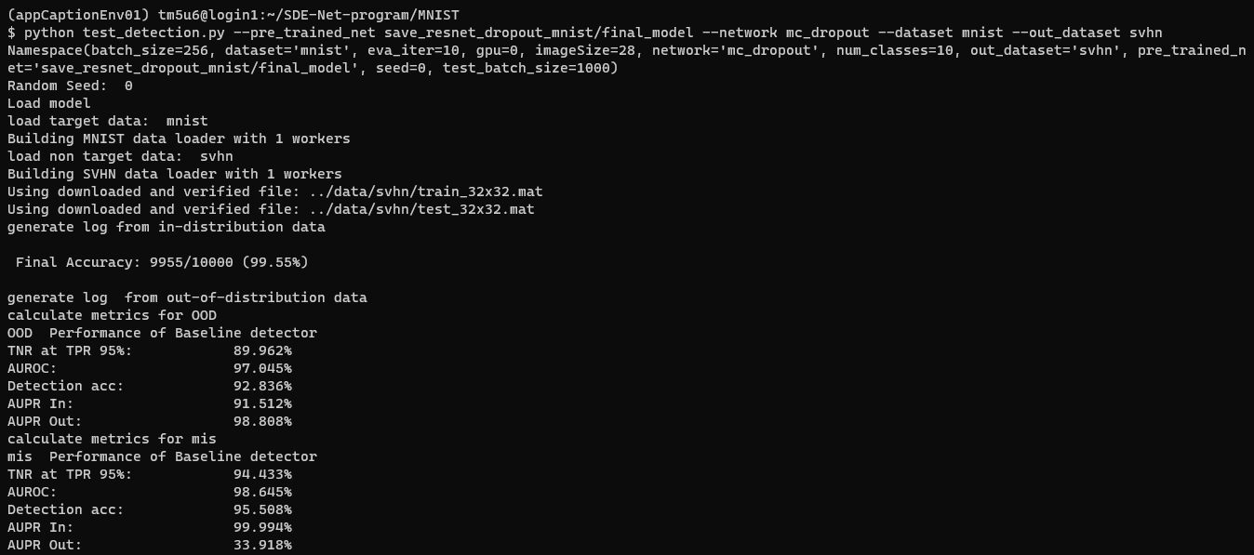

Figure 5. Final Performance results for MC-Dropout in MNIST

* Experiment with MNIST – Training the SDE-Net

Command: $ srun python sdenet_mnist.py > sdenet_mnist.log 2>&1 &

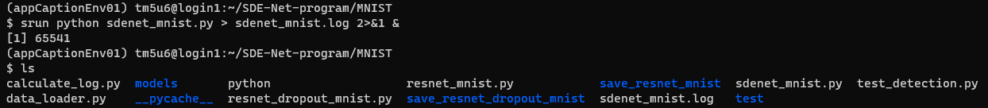

Building and training the model

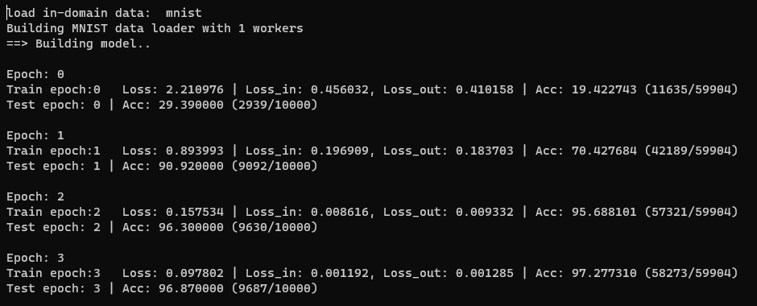

40 epochs after…

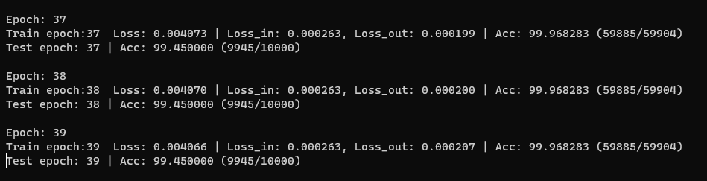

* Experiment with MNIST – Evaluating SDE-Net

Command: $ python test_detection.py --pre_trained_net save_sdenet_mnist/final_model --network sdenet --dataset mnist --out_dataset svhn

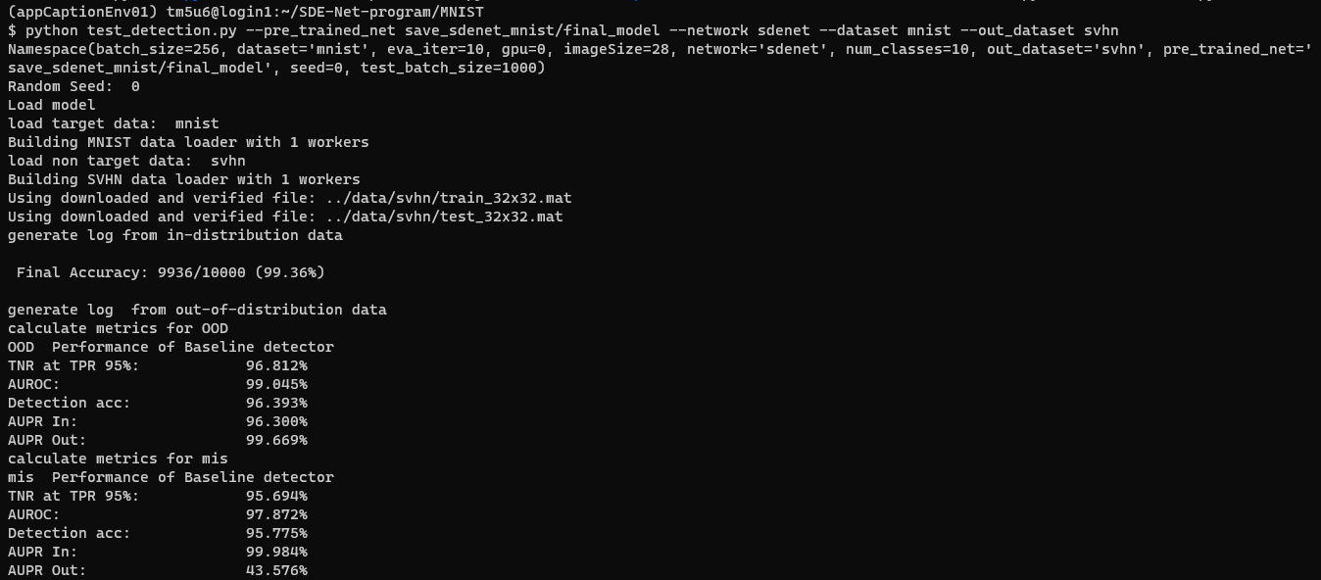

Fig 6. Final performance of SDE-Net in MNIST

**EXPERIMENTS WITH SVHN**

* Experiment with SVHN – Training the Resnet

Command: $ srun python resnet_svhn.py > resnet_svhn.log 2>&1 &



Building and training the model

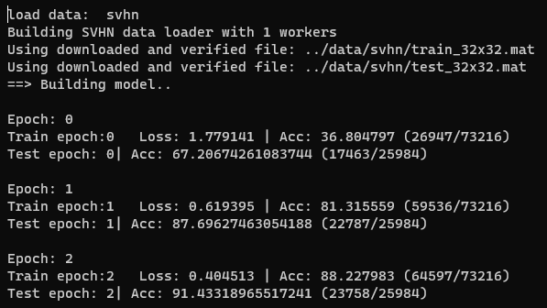

After 60 epochs…

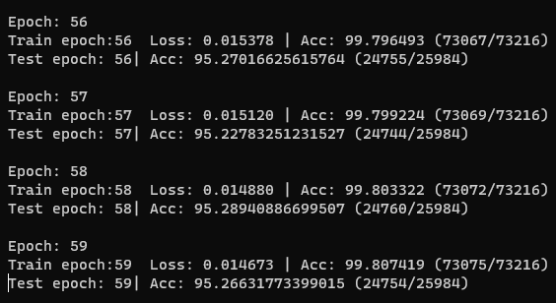

* Experiment with SVHN – Evaluating Resnet

Command: $ python test_detection.py --pre_trained_net save_resnet_svhn/final_model --network resnet --dataset svhn --out_dataset cifar10

Loading CIFAR-10 dataset

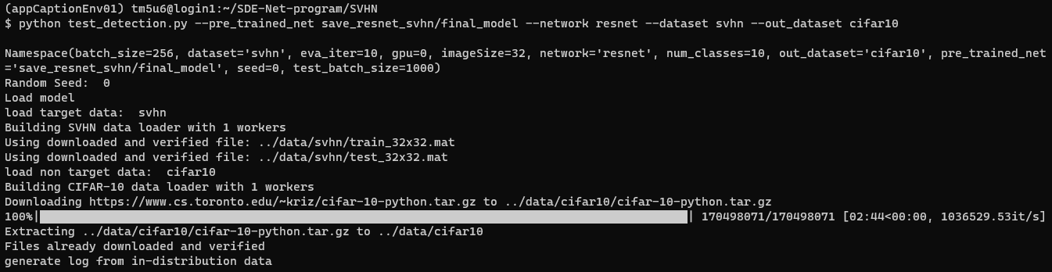

Evaluation

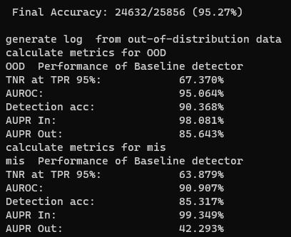

* Experiment with SVHN – Training the MC-dropout

Command: $ srun python resnet_dropout_svhn.py > resnet_dropout_svhn.log 2>&1 &

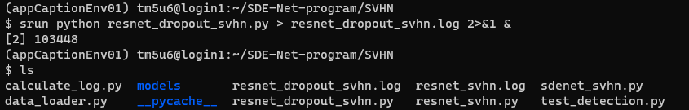

Building and training the model

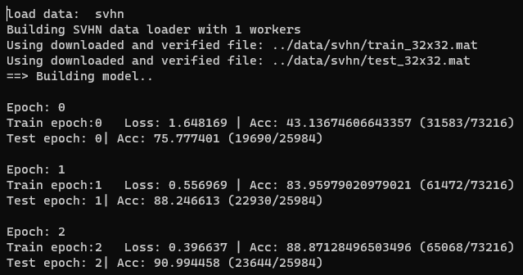

After 60 epochs…

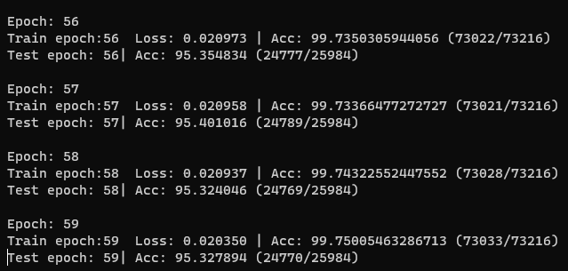

* Experiment with SVHN – Evaluating MC-dropout

Command: $ python test_detection.py --pre_trained_net save_resnet_dropout_svhn/final_model --network mc_dropout --dataset svhn --out_dataset cifar10

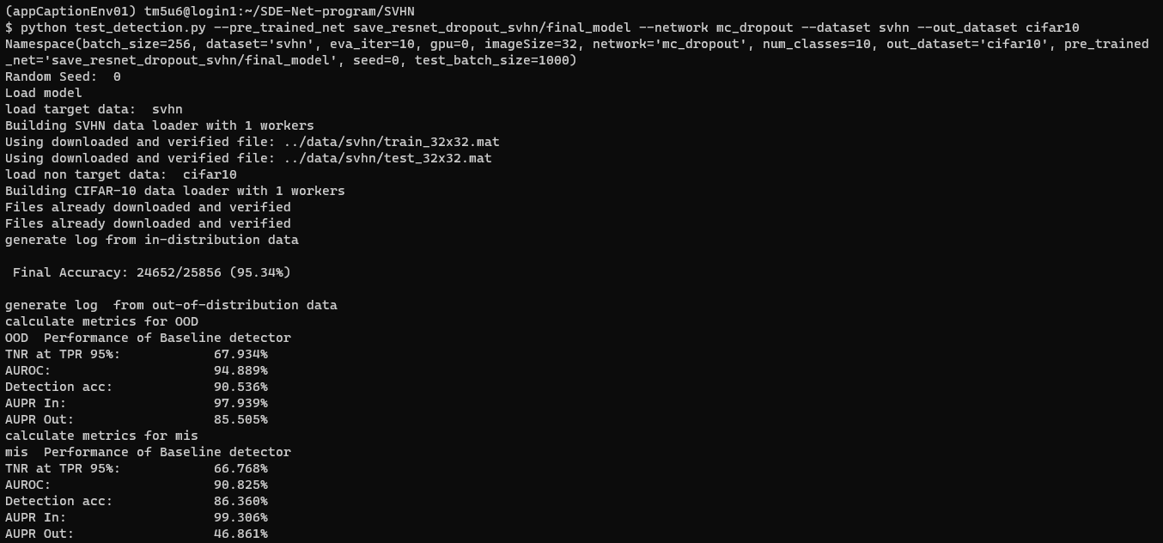

* Experiment with SVHN – Training the SDE-Net

Command: $ srun python sdenet_svhn.py > sdenet_svhn.log 2>&1 &



Building and training the model

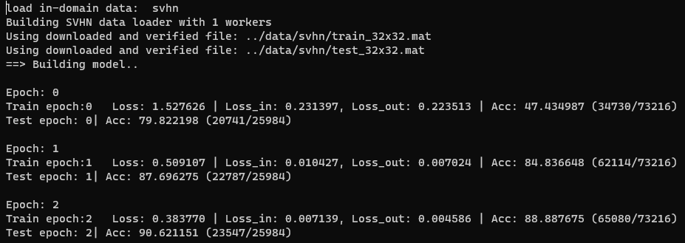

After 60 epochs…

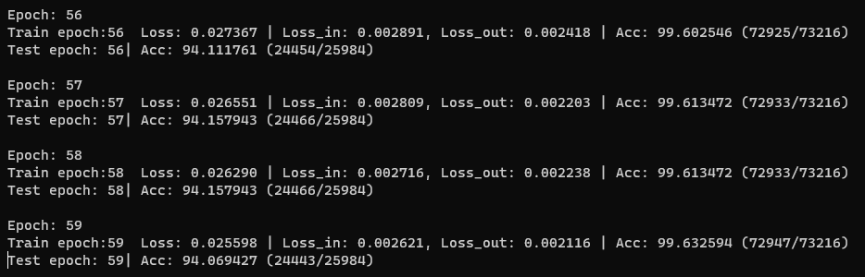

* Experiment with SVHN – Evaluating SDE-Net

Command: $ python test_detection.py --pre_trained_net save_sdenet_svhn_0/final_model --network sdenet --dataset svhn --out_dataset cifar10

